Assessment Service Documentation

Overview
The Assessment Service handles user onboarding through a two-phase self-assessment workflow:

- KB Generation (Step 1) : When a chat session is created, the user's legal situation is classified and a personalized Knowledge Base (KB) is generated.
- Self-Assessment Evaluation (Step 2) : The user fills out a four-dimension form (Facts, Strategies, Procedures, Rationales). Four parallel LLM evaluators score each dimension, and a priority gap is computed to guide the chatbot's responses.

The result of the self-assessment flows into every subsequent chat message, steering the reasoning node toward addressing the user's most critical knowledge gap first.

Folder Structure
ai/self_assessment/
├── router.py # FastAPI route handlers for the two assessment endpoints
├── pipeline.py # All LLM calls and business logic (classifier, KB generator,
│ # auditor, example generator, dimension evaluators)
├── prompts.py # All raw prompt templates used by the pipeline LLMs
└── schemas.py # Pydantic request/response models for all endpoints

backend/apps/chat/
├── views.py # submit_self_assessment(), skip_self_assessment(),
│ # _build_self_assessment_context(), _format_structured_report()
└── ...

backend/
└── ai_client.py # evaluate_self_assessment() and generate_kb() HTTP client methods

File Descriptions

ai/self_assessment/router.py
Defines two FastAPI routes mounted under /self-assessment/:

Endpoint | Purpose
POST /generate-kb | Classifies legal situation, generates KB, returns structured knowledge
POST /evaluate | Accepts four-dimension user input, runs evaluators, returns gap report

- Orchestrates the LLM call sequence (LLM1 -> LLM2+LLM4 in parallel -> optional LLM3 audit).
- Stateless: passes KB content received from Django directly to the evaluators; does not read from MongoDB.

ai/self_assessment/pipeline.py
Contains all LLM wrapper functions and computation logic:

Function | Model | Purpose
run_llm1_classifier() | gpt-4o-mini | Classifies legal_domain, branch, baseline_familiarity, primary_intent
run_llm2_kb_generator() | gpt-4o | Generates full KB: global_highlights, rag_snippets, few_shot_examples, cot_checklist
run_llm3_audit() | gpt-4o-mini | Optional quality audit; triggers KB regeneration if issues are found
run_llm4_example_generator() | gpt-4o-mini | Generates a filled example response and blank template for the self-assessment form
run_dimension_evaluator() | gpt-4o-mini | Single-dimension evaluator; labels each student claim with a knowledge gap label
run_evaluation_pipeline() | : | Runs all four dimension evaluators in parallel via ThreadPoolExecutor
compute_full_priority_from_report() | : | Applies gap weights to produce a ranked priority across dimensions
create_self_assessment_text() | : | Flattens all four dimension inputs into a single student_text string
_safe_parse_json() | : | Robustly extracts JSON from raw LLM output

LLM2 and LLM4 run in parallel via ThreadPoolExecutor(max_workers=2).
The four dimension evaluators run in parallel via ThreadPoolExecutor(max_workers=4).

ai/self_assessment/prompts.py
All prompt templates used in the pipeline. No logic : pure text:

Constant | Used by | Purpose
CLASSIFIER_PROMPT | LLM1 | Classifies domain, branch, intent, familiarity
GENERAL_DOMAIN_INSTRUCTION | LLM2 | Special instruction appended when domain is "general"
KB_GENERATOR_PROMPT | LLM2 | Generates the full structured KB JSON
KB_AUDIT_PROMPT | LLM3 | Validates KB quality; triggers regeneration if poor
EXAMPLE_GENERATION_SYSTEM_PROMPT | LLM4 | Governs the structure of example_text and empty_template
EXAMPLE_GENERATION_GUIDE | LLM4 | FSPR framework guide with domain-specific examples
DIMENSION_EVALUATOR_PROMPT | EVAL_* | Evaluates one dimension using label definitions and KB reference
SELF_ASSESSMENT_TEXT_TEMPLATE | pipeline | Flattens four-dimension input into a readable student_text block

ai/self_assessment/schemas.py
Pydantic models for request/response validation:

Class | Role
GenerateKBRequest | Input to /generate-kb: legal_situation, prior_experience, desired_outcome, jurisdiction, debug
GenerateKBResponse | Output of /generate-kb: domain classification + full KB content
DimensionInput | Per-dimension user input: examples (str) + uncertainties (str)
EvaluateRequest | Input to /evaluate: chat context + kb_content + four DimensionInputs
AspectLabel | One evaluated claim: labels (list) + text
DimensionReport | One dimension's result: dimension, aspects, most_critical_gap
PriorityReport | Final priority: top_dimension, top_label_in_top_dimension, scores, counts
EvaluateResponse | Output of /evaluate: student_text + evaluation_report + priority
LLMCallLog | Debug-mode log entry for each LLM call

backend/apps/chat/views.py (assessment-related functions)
Function | Purpose
submit_self_assessment() | Validates form input, fetches KB from MongoDB, calls AI evaluate, persists result to self_assessments collection, sets status = "completed"
skip_self_assessment() | Sets self_assessment_status = "skipped" on the Conversation; chat falls back to intake-only context
_build_self_assessment_context() | Called before every chat message; assembles the context dict passed to the AI layer (includes priority_focus if status = "completed")
_format_structured_report() | Formats the raw evaluation_report list into a readable string for the reasoning prompt

backend/ai_client.py (assessment-related methods)
Method | HTTP call | Purpose
generate_kb() | POST /self-assessment/generate-kb | Called during chat session creation (Step 1)
evaluate_self_assessment() | POST /self-assessment/evaluate | Called during self-assessment submission (Step 2)

Architecture / Flow Diagram

Step 1
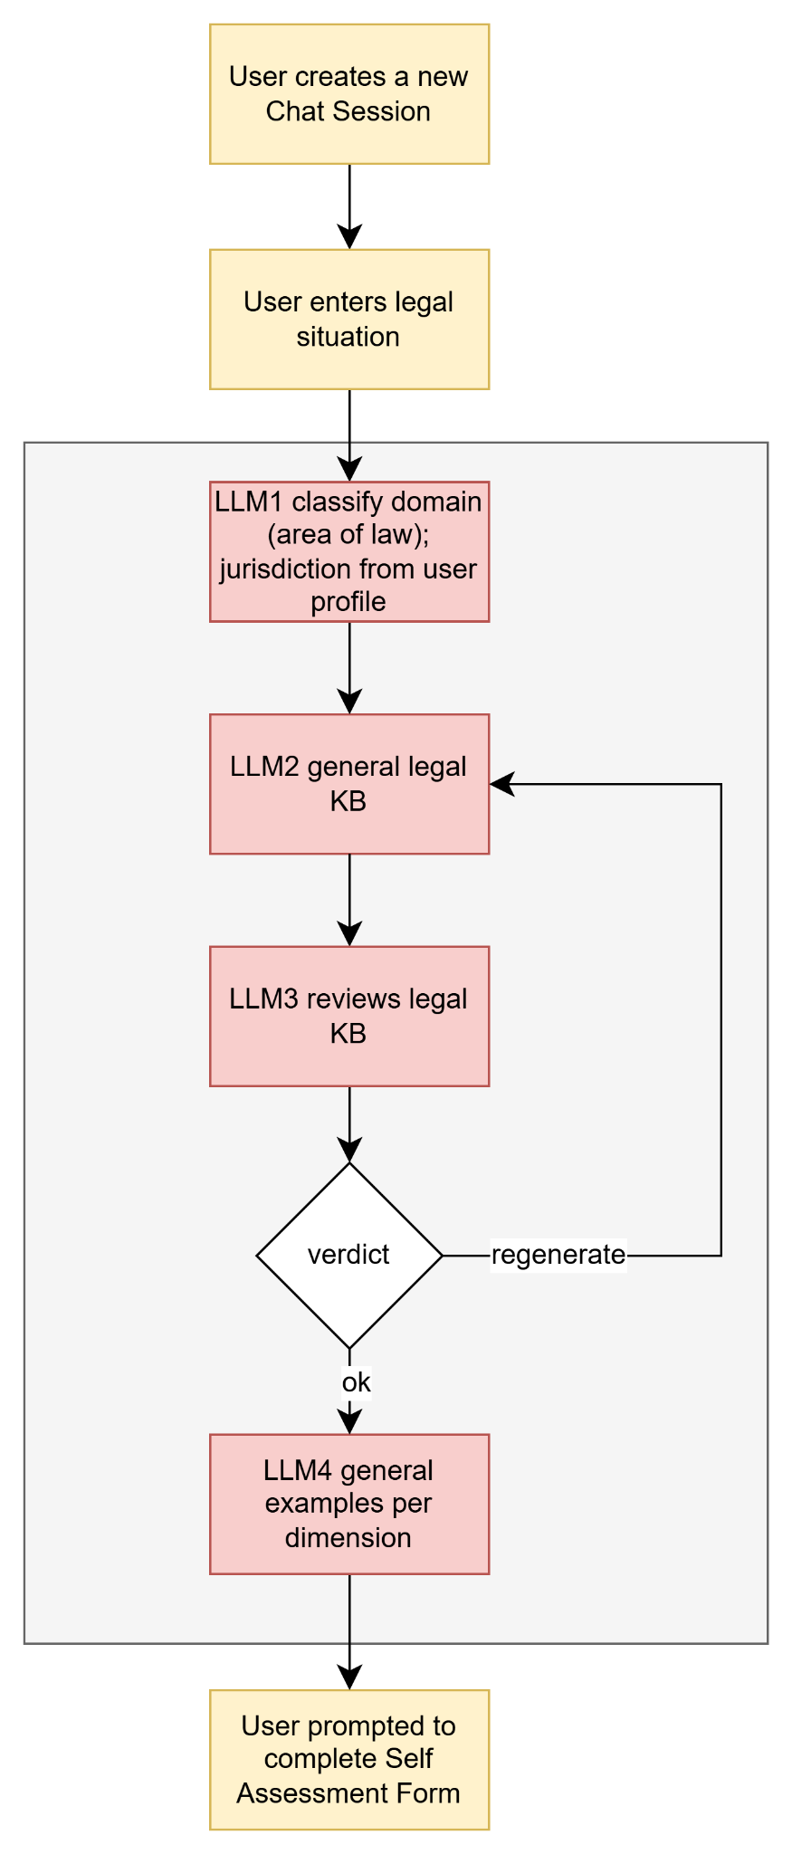

Step 2 : Self-Assessment Evaluation
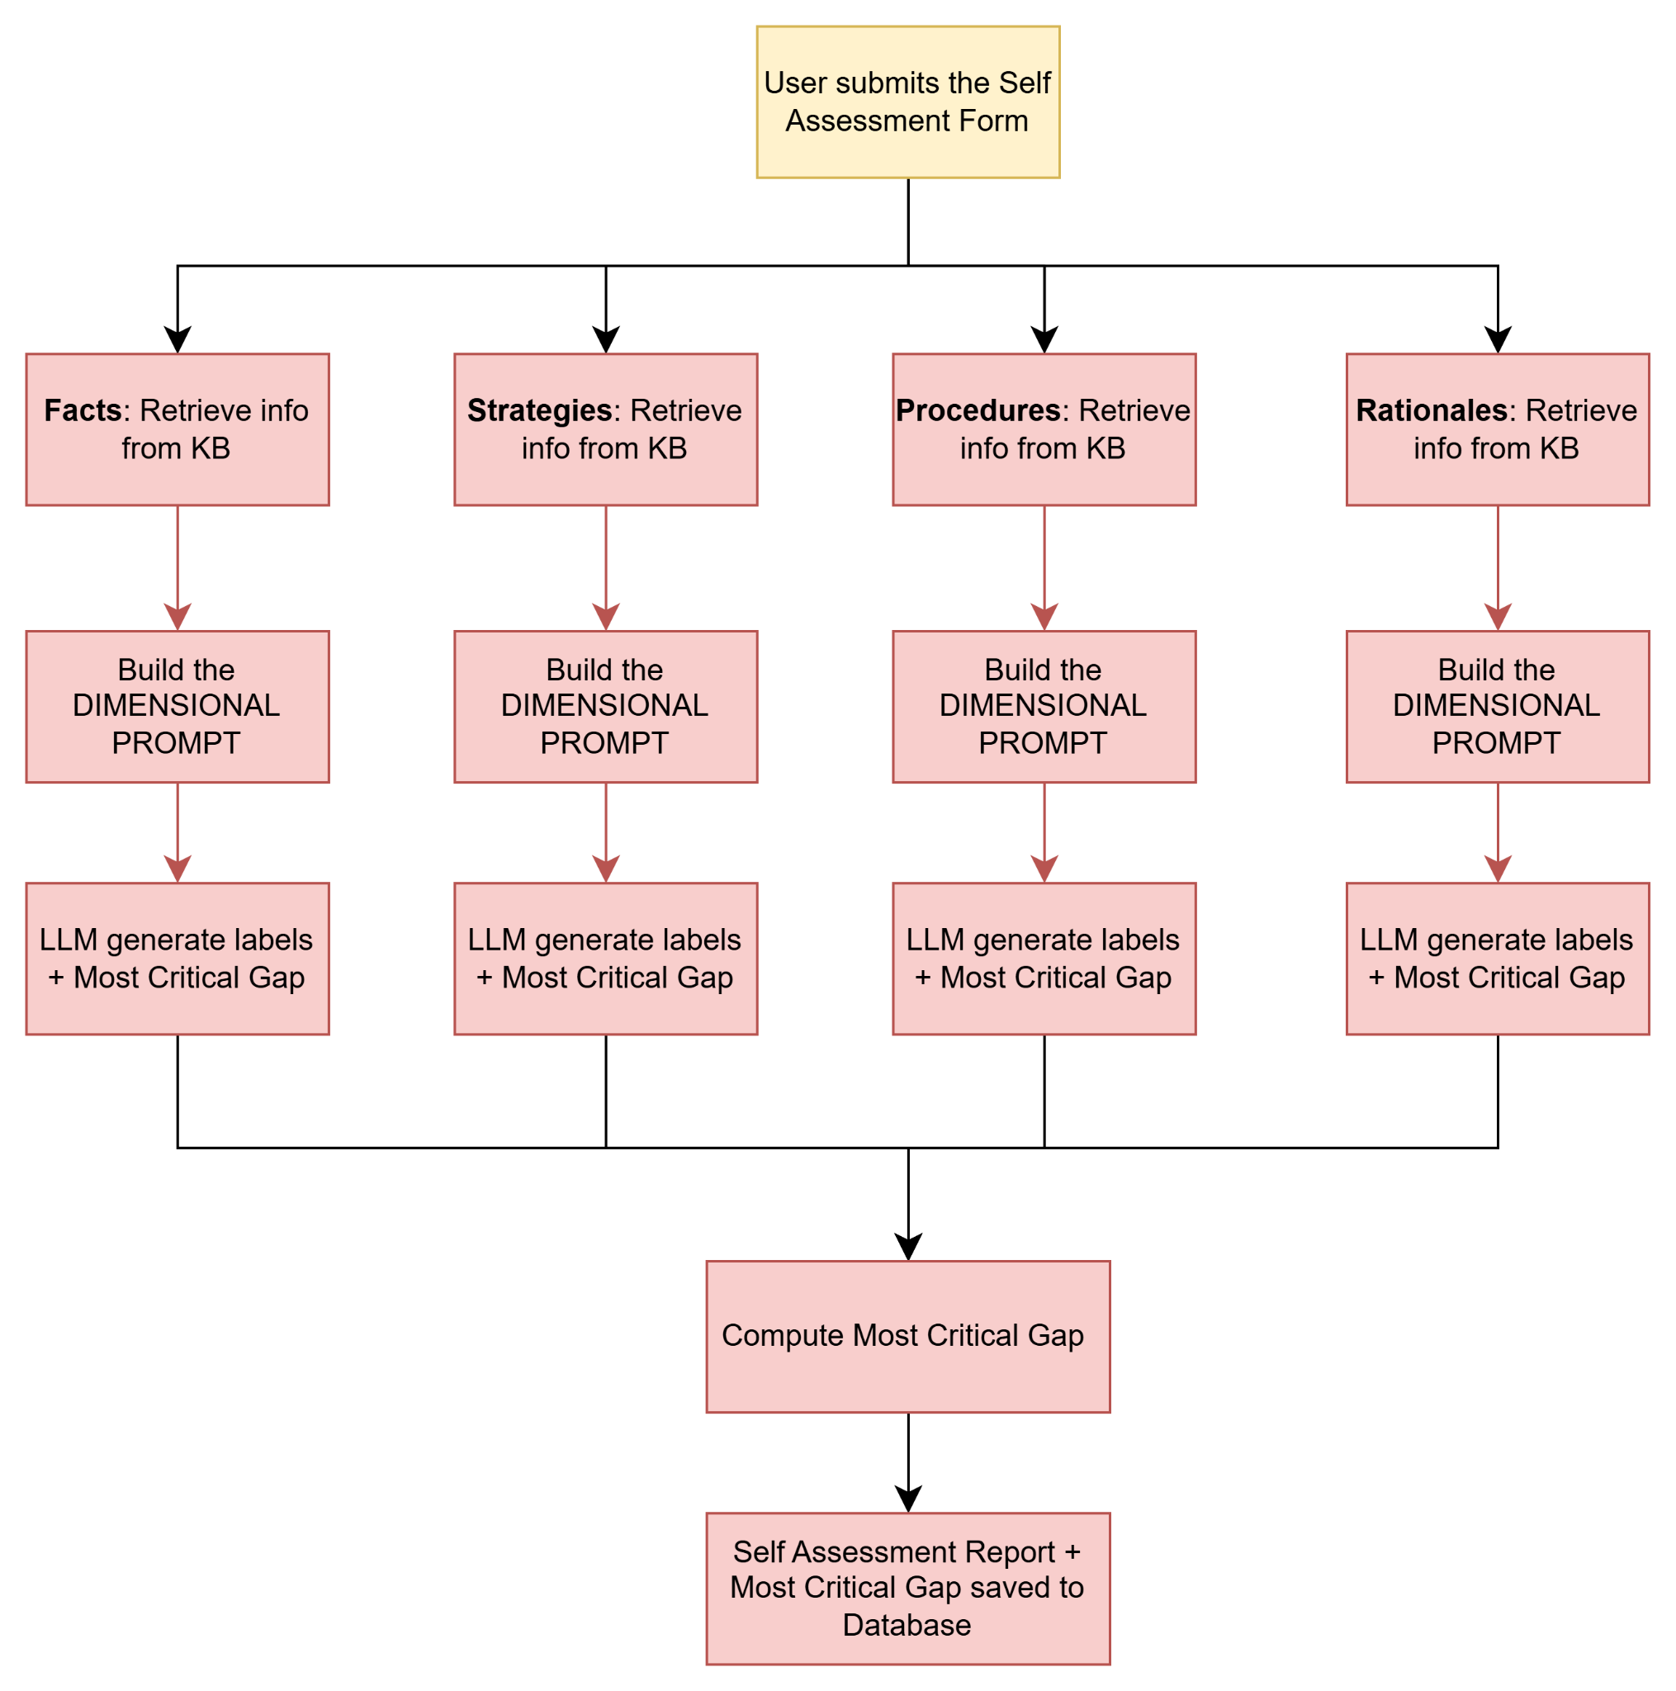

Step 3 : Context Injection into Chat (every message)
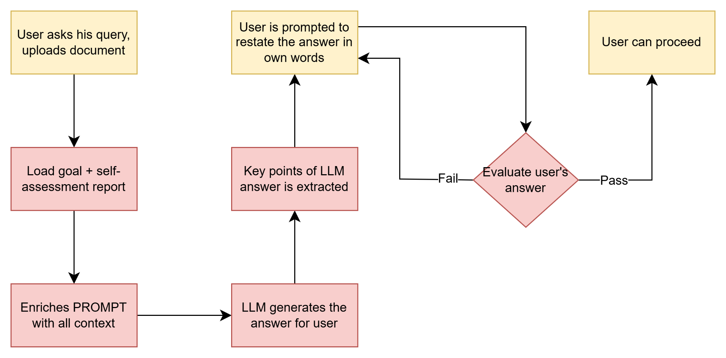

Knowledge Gap Label Definitions
Labels applied by each dimension evaluator:

Label | Meaning | Weight
Know-Know | User correctly understands this aspect | 0.00
Know-Don't Know | User correctly identifies a gap in their own knowledge | 0.20
False Knowledge | User states something incorrect or misleading | 0.40
Omission | User is missing a critical concept they did not acknowledge | 0.30
Irrelevant Knowledge | User includes information not relevant to their situation | 0.10

Priority is computed by summing weights across all aspects per dimension. The dimension with the highest score becomes top_dimension, and within it, the highest-weight label that appears becomes top_label_in_top_dimension.

MongoDB Collections

knowledge_base
Stores generated KBs, reusable across users for the same domain+jurisdiction.

{
"legal_domain": "employment_law",
"jurisdiction": "California",
"title": "...",
"content": {
"global_highlights": ["..."],
"rag_snippets": ["..."],
"few_shot_examples": {
"facts": [{"input": "...", "analysis": "..."}],
"strategies": [...],
"procedures": [...],
"rationales": [...],
"tutor": [...]
},
"cot_checklist": ["..."]
},
"created_at": "ISODate",
"updated_at": "ISODate"
}

Index: (legal_domain, jurisdiction) : unique

self_assessments
Stores one evaluation result per chat session.

{
"chat_id": "...",
"user_id": "...",
"legal_domain": "employment_law",
"jurisdiction": "California",
"student_text": "...",
"evaluation_report": [
{
"dimension": "Facts",
"aspects": [{"labels": ["False Knowledge"], "text": "..."}],
"most_critical_gap": "..."
}
],
"priority": {
"top_dimension": "Facts",
"top_label_in_top_dimension": "False Knowledge",
"dimension_scores": {"Facts": 0.80, "Strategies": 0.30, ...},
"dimension_counts": {"Facts": {"False Knowledge": 2, ...}, ...}
},
"created_at": "ISODate",
"updated_at": "ISODate"
}

Index: chat_id : unique

API Reference

POST /self-assessment/generate-kb
Request:
{
"legal_situation": "string",
"prior_experience": "string",
"desired_outcome": "string",
"jurisdiction": "string",
"debug": false
}

Response:
{
"legal_domain": "string",
"branch": "string",
"jurisdiction": "string",
"baseline_familiarity": "low | medium | high",
"primary_intent": "understand_options | contest | comply | draft | review",
"confidence": 0.0,
"kb_title": "string",
"global_highlights": ["string"],
"rag_snippets": ["string"],
"few_shot_examples": {},
"example_text": "string",
"empty_template": {}
}

POST /self-assessment/evaluate
Request:
{
"chat_id": "string",
"legal_situation": "string",
"legal_domain": "string",
"branch": "string",
"jurisdiction": "string",
"baseline_familiarity": "low | medium | high",
"primary_intent": "string",
"prior_experience": "string",
"desired_outcome": "string",
"kb_content": {},
"facts": { "examples": "string", "uncertainties": "string" },
"strategies": { "examples": "string", "uncertainties": "string" },
"procedures": { "examples": "string", "uncertainties": "string" },
"rationales": { "examples": "string", "uncertainties": "string" }
}

Response:
{
"chat_id": "string",
"student_text": "string",
"evaluation_report": [
{
"dimension": "Facts",
"aspects": [{ "labels": ["False Knowledge"], "text": "string" }],
"most_critical_gap": "string"
}
],
"priority": {
"top_dimension": "string",
"top_label_in_top_dimension": "string",
"dimension_scores": {},
"dimension_counts": {}
}
}

POST /api/v1/chats/{user_id}/{chat_id}/self-assessment/submit/ (Django)
Accepts the same four dimension inputs as EvaluateRequest (minus chat_id, legal_*, kb_content : Django fetches those itself). Returns { "self_assessment_status": "completed" }.

POST /api/v1/chats/{user_id}/{chat_id}/self-assessment/skip/ (Django)
No body required. Returns { "self_assessment_status": "skipped" }.

